Published in: Journal of Social Archaeology, 3, 1, 2003,

Social Archaeology of Housing from a Latin American Perspective: a case study

PEDRO PAULO A. FUNARI

Campinas State University, Brazil

ANDRÉS ZARANKIN

Dipa-Imhicihu-Conicet, Argentina

ABSTRACT
This article discusses the structuring of domination in everyday life, studied through private housing material culture, over a period of several centuries. Our case study deals with the processes of use of space and the changes in middle-class households in Buenos Aires since the late 18th century, highlighting both world and Latin American contexts. We show how morphological and spatial changes in households are related both to the wider world capitalist context and to local conditions, shaping peoples lives. We focus on the controlling features of housing, affecting not only the middle classes but potentially the whole spectrum of social classes. Capitalism tends to individualise space, create private environments, restrict movement and control movement in general and houses as material artefacts reflect these tendencies. We conclude that the study of Buenos Aires housing enables us to note that there has been a growing tendency to restrict circulation within the house, enforcing a controlling , bourgeois way of life.

KEYWORDS
Archaeology of architecture, social archaeology, control, South America.

INTRODUCTION

The challenge of understanding material culture in terms of social context and lived experiences is a major one for archaeology in general (Meskell, Gosden, Hodder, Joyce and Preucel 2001) and particularly so for archaeology in Latin America. Archaeology in Latin America has many strands, with a wide variety of theoretical underpinnings and practices. Sometimes, it is useful to differentiate South America from Central America, the Caribbean and México (e.g. Politis 2001), Spanish-speaking from Portuguese-speaking countries (Funari 1995, 1997; Politis 1995), or else to stress the importance of local social archaeology grown in some countries as “Latin American Social Archaeology” (Bate 1998 and Fournier 1999, with earlier bibliography) as opposed to the importation of interpretive frameworks from every where (Funari 1996; 1997). We here consider Latin America as an Iberian enterprise (Wade 1994: 59) resulting in societies inserted in the modern, capitalist context, but also characterised by a series of patriarchal and hierarchical features, which have shaped unique social mixes (cf. Funari 1998; 1999).

In this context, Argentina offers the opportunity of a particularly productive case study, as Argentine society has for centuries been at the crossroads of the most advanced capitalist and the most traditional patriarchal influences as well (Zarankin 1994; Senatore 1995). Buenos Aires, at the end of the world and at its centre at the same time, is a good place for the development of new social issues. The structuring of domination into everyday activities (Paynter and McGuire 1991: 9; Podgorny 1999) is studied through private housing material culture, over a period of several centuries, trying to outline the main changes over time.

We aim at discussing several aspects related with the material construction of social relationships (Funari 1996), through the study of housing as the architectural creation of a particular cultural environment. We thus consider that artefacts are active, dynamic and that they carry and create meaning (Funari 1986:22-24), there being several studies which state the relevance of approaching material culture from such a critical perspective (Miller 1984, Leone 1986, Austin and Thomas 1986, Hodder 1987, Tilley 1989, Funari 1991; Funari 2000, Andrade Lima 1999).

We also consider that material culture isolated from social context lacks significance and it is only within a cultural system that it acquires an active and ideological dimension (Hodder 1987). In this context, we ask ourselves three main questions, as part of a system of meanings : how are artefacts constructed? how do they change over time and which strategies make them legitimate? We are also interested in understanding the subjectivities contained and generated by material culture (Warnier 2001). In order to answer these questions we must study which references are used by artefacts, and understand in what way artefacts changed over time. We consider that “truths” -in our case “legitimated objects" - are built through different practices among which we include manipulation of the material world (Leone 1984, Miller and Tilley 1984, McGuire and Paynter 1991).

If we consider housing as a part of architecture -being itself a peculiar type of language- (Fletcher 1989, Monks 1992, Markus 1993, Parker Pearson and Richards 1994, Grahame 1995 1997) through the analysis of the processes affecting housing we will be able to understand the significance it has had over time. Human landscape is built and resisted by means of a dialectical game of dominance and resistance (McGuire and Paynter 1991; Orser and Funari 2001). Architecture -as part of the same game- can be approached as the battle field where social strata and their ideologies fight one another. Our case study deals with processes of use of space and changes in middle-class households in Buenos Aires since late 18th century, highlighting both the world (Orser 1996) and Latin American (Zarankin 1997; 1999a; 1999b) contexts.

ARCHAEOLOGY OF ARCHITECTURE: ARCHITECTURE AS TECHNOLOGY OF POWER

In the recent decades, a new study field has been developing under the name of archaeology of architecture (Stedman 1996), offering new analytical perspectives by means of which human environment can be approached. Constructions are viewed as active elements, that is to say cultural products interacting dynamically with people (cf. Rapoport 1969, 1982, 1990a, 1990b; Glassie 1975; Deetz 1977, 1988; Leone 1977, 1984; Hodder 1984, 1994; Kent 1990; Samson 1990; Johnson 1991, 1993; Markus 1993; Parker Pearson and Richards 1994; Blanton 1994; Grahame 1995, 1997, among others). In Argentina. as elsewhere in Latin America, most studies are concerned with typology, but recent research is now discussing the relationship between the spacial-architectural structuring of sites and its socio-political connotations, concluding that manipulation of such elements can work as a vehicle for the creation and maintenance of power relationships and domination (cf. Tarragó 1987; Nielsen 1995; Zarakin 1997, 1999a, 1999b, 2001, 2002, Acuto 1999).

Several recent studies have transcended the descriptive, and the mere intention of highlighting aesthetic attributes in high style buildings (e.g. Maestri 2001; cf. Zarankin 1999a, 2002). From a contextual perspective in archaeology, architecture is to be interpreted as both symbolic and ideological, serving both practical and ideological purposes (Parker Pearson and Richards 1994). Foucault (1976) emphasises that invisible strategies are used to discipline ordinary people and to form disciplined and useful individuals, first and foremost by the use of space as a controlling device (Foucault 1976). The panoptical form is the best example of this controlling trend (Foucault 1976: 204).
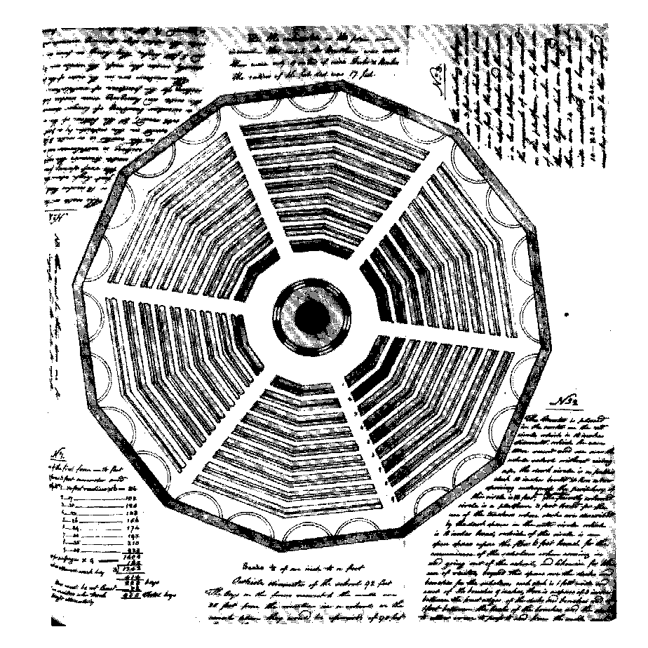

Figure 1: Jeremy Bentham´s (1816) design project of a school (Manuscrits Bentham, U.C.L., Evans plan No. 18).

Grahame (1995) states that architecture contributes to structure the way in which individuals meet physically in space and the design of a building influences the possibilities of relationship among occupants (cf. Hingley 1999: 146). Eco points out that architectural design connotes a global ideology shaping the minds of architects themselves, by means of rules and codes which regulate architectural production (Eco 1968). We move within a given building grammar, encoded in the science of construction (Eco 1968: 365), satisfying people’s demands and at the same time persuading them to live in a certain, controlled way (Eco 1968: 367).

Domestic architecture has been neglected for a long time as a way of understanding social relations but there is a growing tendency to believe that daily actions in a built environment are an important archaeological subject (Samson 1990). Housing is neither neutral nor passive, but active and dynamic and in itself a generator of meaning. The household is a complex power structure which not only shelters people and their belongings but also bears influence on them, specially during the socialization process (Zarankin 1997). As Bourdieu (1977) points out, socialisation is deeply rooted in domestic practices and sexual, social, economic and behavioural habits are shaped by the household. itself. Habitus is thus directly linked to buildings as an opus operatum (Bourdieu 1977:90) and social practices are structured by them (Giddens 1979). Space is loaded with symbolic elements expressing meaning and reproducing inequality (Parker Pearson and Richards 1994).

Architecture as one of the basic components of the human construction of space can be understood as technology of power (Foucault 1976), aimed at having people docilely favour the reproduction of power relationships but also inevitably leading to resistance. "Material culture in the form both of architecture and portable artefacts is routinely read by the people and contributes to the formation of their subjectivity" (Austin and Thomas 1986:46). In this case study we deal with academic design, stressing the strategies of domination embedded in housing design, even though we also acknowledge that resistance-not mentioned in architecture- has always been an active part of housing use. In other words, our analysis is centered on domination strategies, that is to say the type of house designed by both the builder and the system, leaving for further discussion all the matters related to resistance tactics (de Certeau 1980) or to opposition on the side of the occupants.

BUENOS AIRES AS A CASE STUDY

We study middle class households in the city of Buenos Aires, from the late 18th century to the end of the 20th century, showing how morphological and spatial changes in households are related to the wider world capitalist context and to local conditions, shaping people’s lives (Markus 1993). Middle class housing is directly linked to capitalism and to the control and the normative character of the modern world and it plays a role as a model for popular housing. Architects are constantly pulling down slums and shanty towns and building middle class, bourgeois houses, as those studied in this article, so that we here focus on the controlling features of housing which affect not only the middle classes but potentially the whole spectrum of social classes.

As regards the selection of cases for analysis , we want to state that there exists no general consensus among historians of Buenos Aires architecture on the morphological types of middle class households built over time. (Torre Revello 1928, 1934, 1957, Arbide, Arteca and Romero 1985, Diez 1986, Arteca 1991a, Iglesia 1991). In our case three basic models of mono-familiar houses within the Spanish tradition (Diez 1986), which were widely spread among the Buenos Aires middle classes have been analysed: colonial household, also known as ‘viceroyalty’ house, (late XVIII, middle XIX) “chorizo” house (late 19th, early 20th century), and modern house (from the mid 20th century). We must first bear in mind that a “type” is an abstraction in order to build which we consider a number of cases so as to identify basic repeated patterns which differentiate them from the rest. In other words, establishing an “architectonic type” consists in generating an ideal model representing many buildings made according to those basic patterns we have isolated..

PATTERNS FOR THE ANALYSIS OF ARCHITECTONIC STRUCTURES.

Once the types of domestic households have been determined it is necessary to define an appropriate pattern for the analysis of architectonic structures. Although there are different methods for comparing architectural structures (Hillier and Hanson 1984, Hage 1979, Samson 1990, Blanton 1994, among others) the indexes of " Scale ", " Integration " and " Complexity " (4), developed by Blanton (1994), with few adaptations to our case study, proved useful to our objectives and expectations (cf. Zarankin 2001, 2002). These require the application of the " Gamma analysis", proposed by Hillier and Hanson (1984). Basically the pattern established by Hillier and Hanson allows to break down the plant of a building in different cells and to establish communication among these, in order to reach the structure of the building from them.

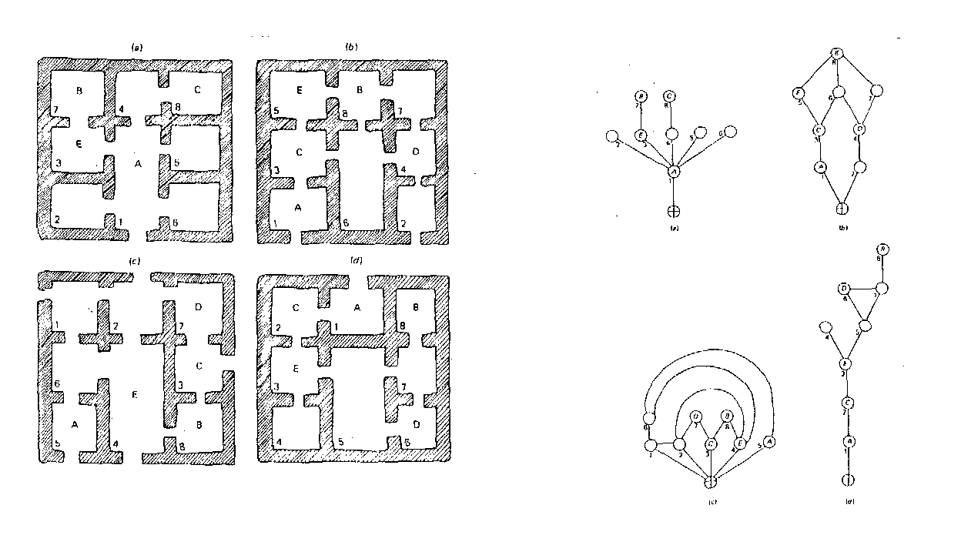
Example of the application of the Gamma method of analysis by Hillier and Hanson.
The diagram shows how four plants that seem similar are quite different structures. (1984:150).

One of the aspects interesting Hillier and Hanson (1984) has to do with the connection characteristics presented by a given architectonic structure. Thus, they consider two types of spatial configurations : distributive and non-distributive.

Non-distributive spaces are those which you can reach or leave only through one opening.

Distributive spaces are those which you can reach of leave through more than one opening.

On studying this characteristic in one given structure, in general we observe that as many distributive as non-distributive spaces are likely to appear- see Gamma analysis picture. Therefore, on analysing a structure it is necessary to make a general evaluation in order to categorize its configuration as distributive or non-distributive- In the cases presented by Hillier and Hanson structures B and C are distributive and A and D are non-distributive.

Distributive structures show high figures of low connections, that is one connection every node, whereas distributive structures present high figures of high connections, that is two or more connections every node.

In those structures defined as distributive, power and control are distributed homogeneously, therefore they are more democratic character (Hillier y Hanson 1984, Markus 1993a). On the other hand, non-distributive structures concentrate power and control heterogeneously , giving priority to some spaces over others so as to rank them hierarchically A further central aspect in this “Gamma analysis” is related to the degree of access to spaces within a given structure. Accessibility is considered according to the remoteness of spaces to the outside. The result has to do with the isolation and access difficulty of each space .

As Grahame points out (1995:62), the application of Hillier and Hanson’s pattern does not consist of a mere translation of designs into schemes and graphics; on the contrary it is a very delicate job which involves both the decisions made by the researcher and the statement of the criteria he used in this process. In our case these decisions imply the generation of a model which will allow us to make a basic reading of the plans in order to establish a morphological comparison

The indexes set by Richard Blanton (1994), which require the application of the Hillier and Hanson pattern, help achieve a comparison of the different architectural structures to one another, and can be summed up as follows:

a) Scale index:
It consists of counting the number of nodes in the diagram. (if possible, the surface of the area and the number of inhabitants should be added), in order to get the measure of square meters per person.

Scale index = number of nodes

b) Integration index: this index is linked to the circulation within the structure and expresses the degree of restraint within it. It is the result of dividing the number of nodes by the amount of doors or passages in the structure. One (1) is the smallest possible figure, because a room has at least one connection. Then, the highest restraint figure is 1, and it decreases as the integration index increases. A way of achieving integration is creating alternative circuits so that many potential routes go from one place to another.

Amount of connections
integration index = ------------------------------
number of nodes

c) Complexity index: in his model, Blanton refers to the functional variation of the usage of space. If the information of activities or specific functionality is scarce, the author proposes that calculations should be based on the degree of accessibility or intercommunication of each node. In this way we know not only the amount of connections in the structure but also the degree of accessibility and the circulation within each node.

Complexity index A = = amount of connections among nodes
Complexity index B = accessibility of each node to the outside (number of spaces that need to be crossed)

Finally, taking the plans of each house as a basis, we generate a “gamma” diagram to which we apply the scale, integration and complexity indexes. The result allows us to compare qualitative and quantitative data among the different “types”, and therefore to observe the changes in buildings over time.
The Colonial House
The Spanish colonial system applied the pattern of the Roman-Pompeyan- courtyard-house with very few structural modifications to the building of houses in Buenos Aires -as well as in many other Latin American towns. (Torre Revello 1928, 1934, 1957, Nadal Mora 1951, Furlong 1969, Diez 1986, Waisman 1997). It consisted of a one-storey house , the front of which looked onto the street. The entrance consisted of a large door opening to a passage. This passage led to the fist yard which was surrounded by the main rooms in the building. Nevertheless, no formal differences among the rooms would mark the function of each one. It was only through decoration, furniture and spatial location that function and hierarchy could be inferred. A second passage opened onto a second yard surrounded by the kitchen , the pantry, the bathroom and the maid’s quarter. In one of the two yards there was an “aljibe”, or cistern, which gathered the water from the roofs and just as the Roman impluvium and the Arab al jib was the source of water to drink.

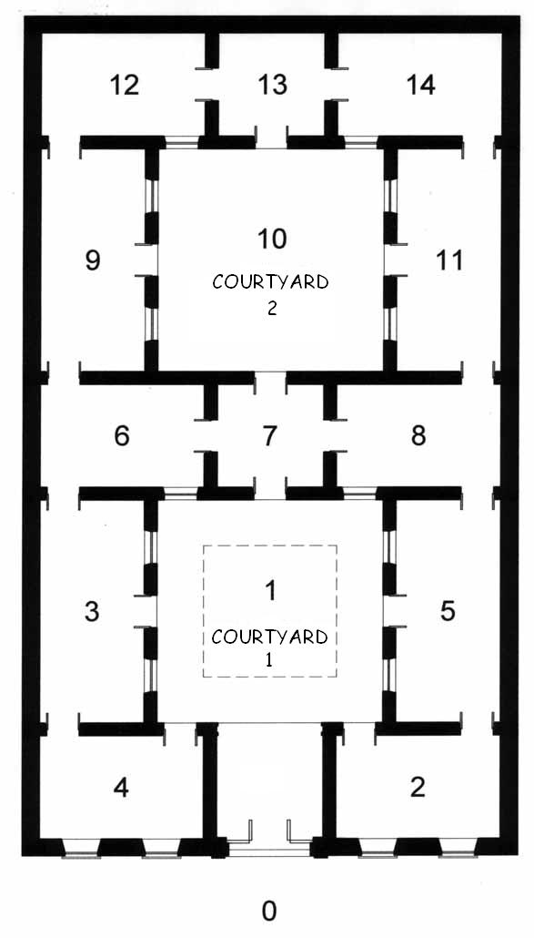 | 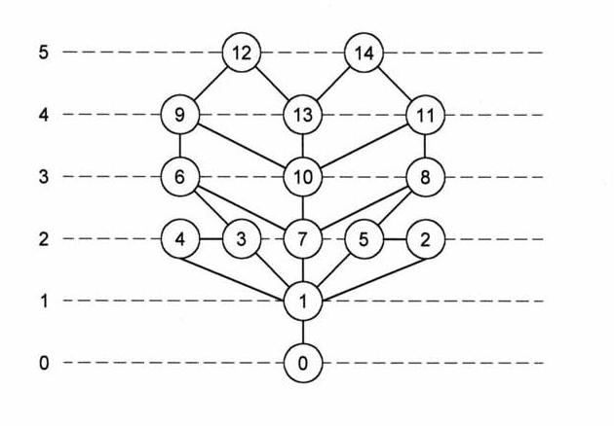
Index of Scale: 14  Index of Integration: 1.57  Index of Complexity A: 45  Index of Complexity B: 3.3 | · Symmetrical plant and structure.  · Number of inhabitants proportional to rooms  · High integration of cells.  · multiple ways of circulation

The structure shows a highly symmetrical plant. The integration and complexity indexes show the degree of interconnection and communication of spaces with one another. Nevertheless, it is worth mentioning that the accessibility average- complexity index B- for this house is 3.3 nodes: that is to say it was necessary to go through 3.3 nodes or spaces in order to reach the street This result must probably be linked to the existence of a back part of the main structure, far away form the outside, which was meant to give housing to servants and slaves.

Both in this house and in the “chorizo” one function and status of rooms and inhabitants are expressed by means of the location and the use of objects – furniture, picture, cutlery mirrors, curtains and so on. This fact shows that the choice of the function for each room depended on its inhabitants (Monks 1992).

The “Chorizo “House

The “chorizo” house or Gringo’s house, appears linked to the growth and consolidation of industrial capitalism during the 19th century and the first half of the 20th century. Several researchers trace its origins to the colonial house; therefore rooms , corridors and yards and their distribution in the house structure repeat patterns which are familiar (Lecuona 1979; Moreno 1997).

The “chorizo” house used to be built over the remains of previous constructions –in those places where there was a previous structure- reusing part of the foundations and some walls (Zarankin, et al. 1998). The yard was still the central axis of the building since all the rooms open onto it. (Lecuona 1979). Nevertheless the yard no longer bore the function of working area, since at that time people already lived and worked at different places, and it might be considered as the survival of past traditions.

As a rule, the entrance door is located to one side of the front of the building which generates an asymmetric pattern.. The idea shown by design is that of an indefinite number of rooms ,equal to one another, which are placed following a longitudinal axis. An open roofed corridor is incorporated as a standard element in this kind of house. The kitchen and the toilet are still placed at the end of the structure

As it was the case in the colonial house, the chorizo house had stability as a building type during several decades and was used as a model in the design of many multifamiliar houses built at the beginning of the 20th century (Diez 1986, Arteca 1991a, 1991b, Arbide, D., G. Aspiazu, and J. García 1991).

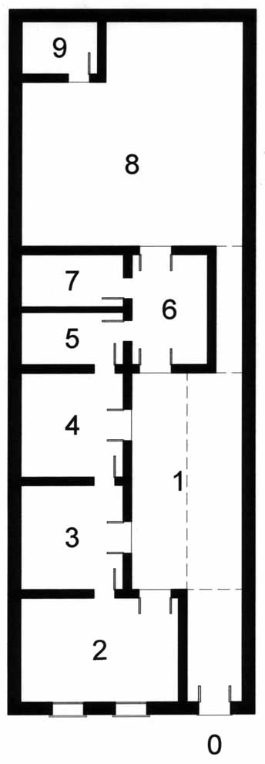 | 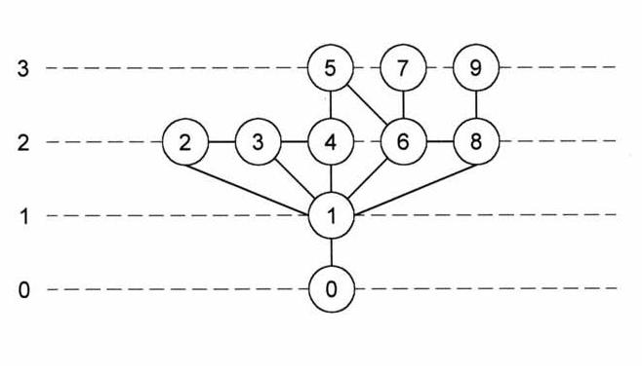
Index of Scale: 9  Index of Integration: 1.4  Index of Complexity A: 25  Index of Complexity B: 2.2 | · Asymmetric plants and symmetrical structure.  · small number of rooms as compared to family size.  · High integration of cells, but lower as compared to the the colonial household.  · alternative circulation circuits.

Unlike the colonial house, the chorizo house has an asymmetric plant. Nevertheless, when analysing the results of the gamma pattern, it can be seen that the structure is still relatively symmetrical There meantime exists a process of reduction in integration and complexity indexes, leading to a higher degree of isolation of nodes with one another when compared to the colonial house . Nevertheless, this house still presents a significant degree of communication of spaces with one another as it appears in the integration index (1.4 which means that each node has almost one and a half connection with other spaces).
Some of the readings which can be done suggest that this house legitimates itself through the use of elements borrowed from previous shapes, included in both design and building: on the one hand central yards and structuring axes around which rooms are placed and on the other re-use of pre-existing structures in the building of the new house. The presence of these features in both the colonial and the chorizo house can be explained as a way of validating the new orders by means of the repossession of previous traditions from different approaches and bearing new meanings.

We believe that this asymmetric plant is related to the increasing social differentiation of the period and above all to the splitting of the living place and the working place (which at the time is the factory) and which becomes a symbol for this division.

The Modern House

The morphology of modern houses shows a radical fracture with previous architectural designs. Based on rational and functional conceptions, (Benton and Benton, 1975) such elements as concrete, iron and glass are used for their building (Moreno 1997). In the facades of such houses the materials they are built with appear uncovered. This fact is related to the conception of international style which considers that decorative elements work as masks covering the building and calling observers’attention to irrelevant aspects of the building. (Frampton 1980). Another important aspect to be considered is that this architecture proposes a complete fracture with previous models stating the need for a compromise with modernity and the future. According to these ideas architecture must be not only a witness but also an agent in the creation of a new society, pleading for a unique ecumenist style (Nuttgens 1983).

Notwithstanding the fact that these principles rule the logic in this movement, there does not exist a single typological pattern for the modern house. Furthermore , if we consider aesthetic aspects there seems to be an infinite number of houses which are absolutely different from one another. Nevertheless, on studying their structure we realise there are common elements repeated once and again. Among these general features which can be identified in most of modern houses are mono-functional rooms, distribution halls and passages, high reaching construction, spaces hierarchically ranked because of their specific characteristics or location, grouping of people according to age, sex and family-position parameters, rooms presenting varied comfort and morphology and a markedly asymmetric plant.

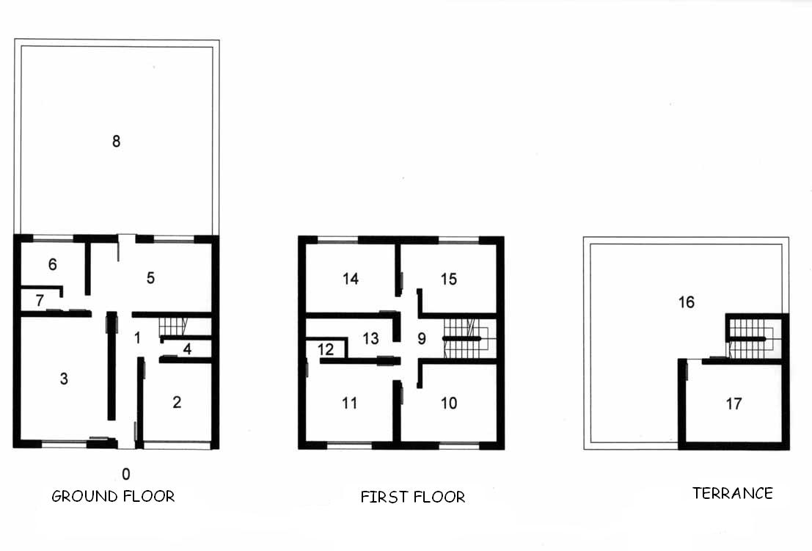 | 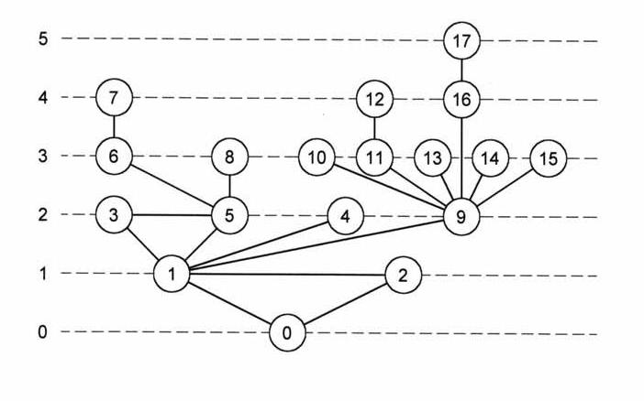
Index of Scale: 17  Index of Integration:1.1  Index of Complexity A: 35  Index of Complexity B: 2.8 | · Asymmetric plant and structure.  · High number of rooms per occupant (two or three rooms for each person  · Low integration of cells  · Alternative circulation circuits tend do disappear and control rooms are introduced, through which circulation is controlled.

This house shows a completely asymmetric plant and structure. It is designed in different floors, each one having a different function and presenting a high number of rooms of varied morphology. Circulation inside the house is achieved by means of “distribution halls”, which are control sectors only through which the different rooms in the house can be reached. When considering the high integration index these houses have, we must bear in mind that this result is influenced by the existence of these halls: the high interconnection of these halls hides the fact that most of the rooms only have one door or connection.

In the modern house the traditional yard has been replaced by the garden, although there exist cases in which this structure can still be found as a roofed yard in the center of the house which helps the airing and lighting of inside rooms. Notwithstanding the fact that facades may be made of brick, concrete, stone or tile, rooms may be round, rectangular of square or decoration may be completely different ,under this apparent heterogeneity the same basic principles of spatial organization are always present ,Underlying an alleged freedom of choice there is a greater control over individuals. In the modern house spaces and their functions are predetermined, for example dining-room, bedroom, garage, and so on. The spatial and morphological characteristics of each room make it difficult to give a space a different function according to one’s own needs. Therefore, occupants are restricted and conditioned at the time of making decisions. This dialectical difference , that is to say between what it is and what it seems makes individuals internalize the inequalities in the system as natural categories

The increase in control over people is achieved by means of the introduction of restrictions both in space and activities. Thus, more control leads to greater restriction. The hierarchical ranking of spaces is another significant variable since it is closely related to pre-established functionality. Rooms that are smaller and smaller and at the same time more heterogeneous keep house occupants away from one another. According to Foucault , discipline is derived basically from the distribution of individuals in space. An effective strategy consists in decomposing collective implantations, avoiding grouping and localizing each individual in one place: “ every individual in his place”. In the author’s own words: “disciplinary space tends to be divided in as many units as bodies or elements to be allotted there are (1976:145-146).

In the design and use of buildings power may eventually be distributed or concentrated in order to produce asymmetry (Markus 1993:23) Thus, inside a house every member’s hierarchy and role is represented by his place inside the structure, by the amount of space and by the type of material objects and comfort inside it Everybody knows that the best room; the one with an adjacent bathroom or the largest, should be used by the parents. A similar differentiation exists among siblings according to variables such as age and sex. Thus, this a mechanism through which the ideas of inequality are made explicit. Individuals are taught to accept and respect the place that has been pre-established for them. Another idea underlying this message is that one day they will be occupying the high rank in the hierarchy , as long as they follow the set rules.

On considering the changes as regards the accessibility to leave and reach the room and the communication the rooms in a house have with one another, there is a clear tendency to non-distributive patterns. In the last examples there is only one door per room, notwithstanding the fact that the modern house has the greatest number of rooms .

CONCLUSIONS

Capitalism as a totalizing system is a formation the structures of which go into and can be found in most of the aspects of social, cultural and economic life (Johnson 1993, 1996). From this perspective changes in architecture- in this case in familiar households-and the development of the capitalist system can be related to each other.

Every type bears sense if we analyze it within the historical and regional context within which it was developed. Therefore, the colonial house of the end of the 18th and the 19th century is related to a mercantilist capitalism, during which a well to do merchant class flourished, the chorizo house is related to an industrial capitalism and the modern house to a monopolistic-cybernetic capitalism (as was defined by us as from Forrester, 1996,2000). The basic socioeconomic aspects of each period can be observed in the following chart:

Social context  Mercantile capitalism  Period  18th-century and first half of 19th century.  Historical context  -1776 creation of the Viceroyalty of La Plata.  -trade based on buying cheap to selling expensive.  Trade monopolised and controlled by Spain.  -settlement and growth of merchants of diverse origins.  -importance of smuggling.  -importance of the harbour.  Family  -Extended family comprising dependants and centred around a patron.  - Patriarchal -organization  Hierarchical organisation based in family origins rather than in money, old stock privileges. | Social context  Industrial capitalism  Period  -End of the second half of the 19th century and beginning of the 20th century  Historical context  -consolidation of the industrial pattern based on industrial production.  -growth and consolidation of the proletariat.  Population –growth.  Expansion of the city of Buenos Aires and surrounding areas (Greater Buenos Aires).  -arrival in the country of large numbers of European immigrants.  Industrial impulse to the country soon after the world wars.  -importance of the port and railway  Family  -Extended family comprising several nuclear units belonging to the same lineage. | Social context  Cybernetic capitalism  Period  -Second half of the 20thcentury and most notably from the 1970s.  Historical context  -increasing specialisation of products and professionals.  -expansion of multinational companies and take-overs of small and medium-sized companies. Monopolies.  Unequal competition.  - spreading of information technology.  -development of the mass media and means of transport.  -concentration of benefits and power in hands of a reduced technocrat elite.  Increase in social inequality and social exclusion of poor strata, cast out of the economic system.  Family  -Nuclear family, usually composed of parents and two to three children.

Transformations taking place in aspects such as space segmentation, asymmetry in plants and structures of buildings, hierarchical space allocation, institutionalisation of pre-established functions among others -if those are considered as non-verbal communication models- (Fletcher 1989) allow us to interpret the deep structures present in architectural language. Thus, comparing the results obtained, certain tendencies which have lasted during time may be observed:

- There is a tendency to make spaces cellular (Foucault 1976) This means that there are more spaces as related to the number of occupants ( in a house the average is 2 or 3 rooms per person) Furthermore these spaces tend to have specific pre-established functions (laundry-room, dining-room, bedroom, study, etc) as well as different degrees of comfort

- There is a fall in the integration index along time. This clearly shows an increase in the restriction in connection of spaces with one another. Thus: a) alternative circuits of inside circulation disappear, b) some rooms (halls of distribution ) become unavoidable.

- Another aspect to be considered is the degree of access or remoteness to the outside of the different rooms in the house. This is clearly seen in modern houses which present high complexity indexes (number of spaces to leave the house) and panoptic structures.

-A last item to be considered is the composition of the family occupying the houses under study. As a general rule the number of occupants of the houses studied tend to diminish in time .Several social scientists relate this process- which can be seen in western societies at world scale- to the economic, political and ideological needs of the system (Lawrence 1990).

Thus, the tendencies observed in design show an increase in the restrictive aspects, as a means of materializing the control criteria.; among which the isolation of activities and individuals can be particularly mentioned. This is achieved by means of different mechanisms such as addition of spaces or subdivision of the existing ones. The relationship between growth of control elements and architectonic design, in the modern house, is materialized through fixed elements such as walls , semi-fixed ones such as pieces of furniture and non-fixed ones such as behaviours. (Monks 1992). In the case of colonial and chorizo houses this relationship could only be measured by means of the second and third categories The use of fixed elements in modern houses may be interpreted as the legitimation and formalization of the inequality principles. From a structural point of view these changes reflect the increase in complexity and in social differentiation among individuals groups and classes in society (McGuire y Schiffer 1983).

Summarizing, this comparison makes evident a continuous process of transformation aiming at a non-distributive, restrictive and asymmetric model of house of which the modern house is the clearest example.

FINAL WORDS

Karl Marx once said that “the architect builds the cell in his mind before he constructs it in wax” (Marx [1867] 1976: 284) and the minds of architects are shaped by ruling ideas: also der Verhältnisse, die eben die eine Klasse zur herrschenden machen, also die Gedanken ihrer Herrschaft (Marx [1847] 1976: “hence of the relations which make the one class the ruling one, therefore, the ideas of its dominance”).

The household is central for the reproduction of the social system and the symbolic power associated to it strongly contributes to the internalisation of social rules (Bourdieu 1989), disciplining people into social life. Changes in world capitalism are directly reflected in academic housing patterns and increasingly the family household can be considered as a disciplining device (Foucault 1976; Grahame 1995). As Donley-Reid (1990) has suggested, it is possible to relate morphological changes in household plants to changes in society at large, especially to global capitalism.

From this perspective the changes along time in middle-class, familiar households are sending messages linked to the handling and exercising of power. They have also worked as a self-disciplining strategy of the bourgeois, which has been later expanded (as real and universal truths ) to the rest of society. Following this approach the familiar household may be considered as a disciplining/ taming element of the system which uses aspects linked to feeling and every day life to achieve its goals.

“Disciplining, not in the sense of an obligation forced down on the individual, but kept through a symbolic domination which tends to be a more effective and in some sense a more brutal oppression” (Bourdieu, in Funari 1991:124)

It is clear that in order to guarantee the working and reproduction of the capitalist system, the idea of inequality among individuals should be accepted as a natural, unquestionable category. In this sense the familiar household plays a fundamental role as a taming/disciplining element of the system, the ideological effect of which, once internalised, will be present along the whole of every individual’s life. Foucault said, referring to the effect of prison architecture over convicts (1976:204)

“...prisioners are in a power situation, being themselves agents of their own submission”

Finally we can say that a social archeology of housing can play a major role in both the future archaeological research in Latin America and in contributing to engagement with society in order to empower and emancipate people (Miller & Tilley 1996:11; Funari 1993; 1994; 2002). We are satisfied if this article is a step in this direction.

ACKNOWLEDGEMENTS

We would like to thank the following colleagues: David Austin, Luis Felipe Bate, Mark Grahame, Richard Hingley, Matthew Johnson, Mário Maestri, Randall McGuire, Lynn Meskell, Charles E. Orser, Jr., Irina Podgorny, Gustavo Politis, Colin Richards, Amalia Sanguinetti de Bórmida, María Ximena Senatore, Peter G. Stone, Peter Wade, as well as five anonymous referees. The ideas presented here are our own, for which we are therefore solely responsible. We must also acknowledge the institutional support of the São Paulo State Science Foundation (FAPESP), the Brazilian Science Foundation (CNPq), the Argentine Science Foundation (CONICET), and the University of Campinas (UNICAMP). Finally particular thanks to Lorena Connolly for her help in the translation of sections of this paper from the Spanish language into English.

Referentes

Andrade Lima, T. (1999) “El huevo de la serpiente: Una arqueología del capitalismo embrionario en el Rio de Janeiro del siglo XIX”, in Zarankin, A and F, Acuto (eds). Sed Non Satiata; Teoría Social en la Arqueología Latinoamericana Contemporánea, pp. 189-238. Buenos Aires: Del Tridente,.
Arbide, D. (1991a) “Tipologia Arquitectonico; La técnica del análisis tipológico: la Casa Cajon”, in D. Arbide. (ed), De tipos y Tipologías en la Vivienda Popular, pp 14-25. Concepción del Uruguay: Facultad de Arquitectura y Urbanismo.
Arbide, D. (1991b) “La vivienda popular en Buenos Aires en la década de 1930”, in D. Arbide (ed), De tipos y Tipologías en la Vivienda Popular, pp 6-9. Concepción del Uruguay: Facultad de Arquitectura y Urbanismo.
Arbide, D., Arteca, R. and Romero, G. (1985) “De tipos y Transformaciones de la Casa Chorizo a la Casa Cajón”, in Documentos de Arquitectura Nacional y Americana, 20:29-31. Buenos Aires: Instituto Argentino de Investigaciones en Historia de la Arquitectura,.
Arbide, D., G. Aspiazu, and J. Garcia. (1991) “La casa chorizo; Una tipología para la ciudad”, in De tipos y Tipologías en la Vivienda Popular, in D. Arbide (ed), De tipos y Tipologías en la Vivienda Popular, pp 1-5. Concepción del Uruguay: Facultad de Arquitectura y Urbanismo.
Austin, D. and Thomas, J. (1986) “The “proper study” of medieval archaeology: a case study”. in D. Austin and L. Alcock (eds) From the Baltic to the Black Sea, studies in medieval archaeology, pp. 44-78. London:Unwin Hyman.
Bate, L.F. (1998) El Processo de Investigación en Arqueología. Barcelona: Crítica.
Blanton, R. (1994) Houses end Households. New York: Plenum Press,.
Birdwell-Pheasant, D. and D. Lawrence-Zuñiga (1999) HouseLife; Space, Place and Family in Europe. Oxford: Berg.
Bourdieu, P. (1977) Outline of a Theory of Practice. Cambridge: Cambridge University Press.
Bourdieu, P. (1989) O Poder Simbólico. Río de Janeiro: Bertrand Brasil.
De Certeau, M. (1980) La Invención de lo Cotidiano; 1 Artes de Hacer. México: Universidad Iberoamericana.
Deetz, J. (1977) In Small Things Forgotten. New York: Anchor Books.
Deetz, J. (1988) “Material Culture and the Worldwide in Colonial Anglo-America”, in M, Leone and P, Potter (eds) The Recovery of Meaning, pp. 210-233. Washington D.C.: Smithsonian Institution Press.
Diez, F. (1986) Buenos Aires y Algunas Constantes en las Transformaciones Urbanas. Buenos Aires: Editorial de la Universidad de Belgrano.
Donley-Reid, L. (1990) “A Structuring Structure: the Swahili house”, in S. Kent (ed) Domestic Architecture and the Use of Space. New Direction in Archaeology. Cambridge: Cambridge University Press.
Eco, U. (1968) La Estructura Ausente. Barcelona, Lumen.
Fletcher, R. (1989) “The Messages of Material Behaviour: a Preliminary Discussion of Non-verbal Meaning”, in I. Hodder (ed) The Meaning of the Things, pp. 33-39. Harper Collings.
Forrester, V. (1996) El Horror Económico. México: Fondo Económico de Cultura.
Forrester, V. (2000) Una Extraña Dictadura. México: Fondo Económico de Cultura.
Foucault, M. (1976) Vigilar y Castigar. El Nacimiento de la Prisión. México: Siglo XXI,.
Fournier, P. (1999) “La Arqueología Social Latinoamericana: caracterización de una posición teórica marxista”, in A. Zarankin and F. Acuto (eds.) Sed non satiata. Teoria Social en la Arqueología Latinoamericana Contemporánea, pp17-32. Buenos Aires: Ediciones Del Tridente.
Frampton, K. (1980) Modern Architecture: A Critical History. London: Thames and Hudson.
Funari, P. (1991) “El Mito Bandeirante: Elite Brasileña, Cultura Material e Indentidad”, Boletín de Antropología Americana, 24:112-121.
Funari, P.P.A. (1986) Arqueologia. São Paulo: Ática.
Funari, P.P.A. (1993) “Memória Histórica e cultura material”, Revista Brasileira de História, 13, 25/26, (set.92/ago.93), 17-31.
Funari, P.P.A. (1994) “Rescuing ordinary people's culture: museums, material culture and education in Brazil”, in Peter G. Stone & Brian L. Molineaux (ed), The Presented Past, Heritage, museums and education, Londres, Routledge, 120-136.
Funari, P.P.A. (1995) “Mixed features of archaeological theory in Brazil”, in P.J. Ucko (ed) Theory in Archaeology, A world perspective, 236-250. Routledge: London.
Funari, P.P.A. (1996) “Historical Archaeology in Brazil, Uruguay and Argentina”, World Archaeological Bulletin, 7, 51-62.
Funari, P.P.A. (1997) “Archaeology, History, and Historical Archaeology in South América”, International Journal of Historical Archaeology, 1,3: 189-206, 1997.
Funari, P.P.A. (1998) “A herança medieval do Brasil: mentalidades, usos e costumes feudais, Resenha de Luis Weckmann, La Herencia medieval del Brasil”, Locus, 6: 137-143.
Funari, P.P.A. (1999) “Historical archaeology from a world perspective”, in P.P.A Funari, M. Hall & S. Jones (eds), Historical Archaeology, Back from the edge, 37-66. London, Routledge.
Funari, P.P.A. (2000) Comment to “A critical archaeology revisited”, by L. A. Wilkie and K. Bartoy, Current Anthropology, 41,5:764-765.
Funari, P.P.A. (2001) “Public archaeology from a Latin American Perspective”, Public Archaeology, 1: 239-243.
Funari, P.P.A. (2002) “Class interests and struggle in Brazilian archaeology”, International Journal of Historical Archaeology (in press).
Furlong, G. (1969) El Transplante Social. Buenos Aires: TEA.
Giddens, A. (1979) Central Problems in Social Theory: Action Structure and Contradiction in Social Analysis. London: Macmillan.
Glassie, H. (1975) Folk Housing in Middle Virginia. University of Tennessee Press, Knoxville.
Grahame, M (1997) “Public and private in the Roman house: the spatial order of the Casa del Fauno”, Journal of Roman Archaeology, supplement 22 : 137-164.
Grahame, M. (1995) The House of Pompeii : Space and Social Interaction. Unpublished Ph.D Thesis, Faculty of Arts, Departament of Archaeology, Southampton University, England.
Hage, P. 1979 “Graph Theory As Estructural Model in Cultural Anthropology”, Annual Review of Anthropolgy 8:115-136.
Hillier, B. and Hanson, J. (1984) The Social Logic of Space. Cambridge: Cambridge University Press.
Hingley, R. (1999) “The imperial context of Romano-British studies and proposals for a new understanding of social change”, in P.P.A Funari, M. Hall & S. Jones (eds), Historical Archaeology, Back from the edge, 137-150. London, Routledge.
Hodder, I. (1984) “Burials, Houses, Women and Men in the European Neolithic”, in D. Miller and C. Tilley (ed) Ideology, Power and Prehistory. Cambridge: Cambridge University Press.
Hodder, I. (1987) The Archaeology of Contextual Meanings. New Direction in Archaeology. Cambridge: Cambridge University Press.
Hodder, I. (1994) “Architecture and Meaning: The Example of Neolithic Houses and Tumbs”, in Parker Pearson, M. y C. Richards(eds) Architecture and Order; Aproaches to Social Space, pp. 73-86. London: Routledge.
Iglesia, R. (1991) Identidad Cultural y Construcción del Habitat: Orientándose en el Laberinto. Buenos Aires.
Johnson, M. (1991) “The Englishman’s home and its study”, in Ross Samson (ed) The Social Archaeology of Houses. Edinburgh: Edinburgh University Press.
Johnson, M. (1993) Housing Culture: Traditional Houses in and English Landscape. Washington DC: Smithsonian Press.
Johnson, M. (1994) “Ordering houses, creating narratives”, in M.Parker Pearson and C. Richards (eds) Architecture and Order, 170-177. London: Routledge.
Kent, S. (1990) Domestic Architecture and the Use of Space. New Direction in Archaeology. Cambridge: Cambridge University Press.
Leone, M. (1977) “The New Mormon Temple in Washington D.C., in L.. Ferguson (ed) Histórical Archaelogy and the Importance of Material Things, Special Publication Series (2):43-61. Arizona: Society for Histórical Archaeology.
Leone, M. (1984) “Interpreting Ideology in Histórical Archaeology: the William Paca Garden in Annapolis, Maryland”, in D. Miller y C. Tilley (eds) Ideology, Power and Prehistory, 25-35. Cambridge: Cambridge University Press.
Leone, M.P. (1986) “Symbolic, structural, and critical archaeology”, in D.J. Meltzer, D.D. Fowler and J.A. Sabloff (eds) American Archaeology, Past and Future, 415-438. Washington: Smithsonian.
Maestri, M. (2001) O sobrado e o cativo. A Arquitetura urbana erudita no Brasil escravista. O caso gaúcho. Passo Fundo: Universidade do Passo Fundo.
Markus, T. (1993) Buildings and Power; Freedom and Control in the Origin of Modern Buildings Types. Oxford: Blackwell.
Marx, K. [1847] (1976) The German Ideology. Moscow, Progress Publishers.
Marx, K. [1867] (1976) Capital: a Critique of Political Economy, volume 1, Hardmondsworth, Penguin.
McGuire, R. and Paynter, R. (1991) The Archaeology of Inequality. Blackwell.
McGuire, R. and Schiffer, M. (1983) “A Theory of Architectual Design”, Journal of Antropological Archaeology, 2:277-303.
Meskell, L., Gosden, C., Hodder, I., Joyce, R., Preucel, R. (2001) Editorial statement, Journal of Social Archaeology, 1, 1, 2001, 5-12.
Miller, D. (1984) Modernism and Suburbia as Material Ideology, in D. Miller and C. Tilley (ed) Ideology, Power and Prehistory, pp 37-49. Cambridge: Cambridge University Press.
Miller, D. & Tilley, C. (1996) Editorial, Journal of Material Culture, 1, 5-14.
Monks, G. (1992) “Architectual Simbolism and Non-verbal communication at Upp.er Fort Garry”, Historical Archaeology, 26 (2):37-57.
Nadal Mora, V. (1951) Estetica de la Arquitectura Colonial y Poscolonial Argentina. Buenos Aires: El Ateneo.
Nielsen, A. (1995) “Architectural Perfonmance and Social Reprduction of Power”, in J. Skibo, W. Walker and A. Nilsen (eds) Expanding Archaeology. Utah: University of Utah Press.
Nuttgens, P. (1983) Historia de la Arquitectura. Madrid: Ediciones Destino.
Orser Jr., C.E. (1996) A Historical Archaeology of the Modern World. New York: Plenum Press.
Orser, C.E. Jr. and Pedro Paulo A. Funari (2001) “Archaeology and slave resistance and rebellion”, World Archaeology, 33: 61-72.
Parker Pearson, M. and C. Richards (eds) (1994) Architecture and Order; Aproaches to Social Space. London: Routledge.
Paynter, R. and McGuire, R. (1991) “The archaeology of inequality: material culture, domination, and resistance”, in R. Paynter and R. McGuire (eds) The Archaeology of Inequality, 1-27. Oxford: Blackwell.
Penrose, J. (1992) “Essential constructions? The ‘cultural bases’ of nationalist movements”, Nations and Nationalism 1:391-417.
Podgorny, I. (1999) Arqueología de la educación. Textos, indicios, monumentos. Asociación Argentina de Antropología: Buenos Aires.
Politis, G. (1995) “The socio-politics of the development of archaeology in Hispanic South America”, in P.J. Ucko (ed) Theory in Archaeology, A world perspective, 197-235. London.
Politis, G. (2001) “On archaeological praxis, gender bias and indigenous peoples in South America”, Journal of Social Archaeology, 1,1: 90-107.
Rapoport, A. (1969) House Form and Culture. London: Prentice-Hall, Inc.
Rapoport, A. (1982) The Meaning of Built Environment: A Nonverbal Communication Approach. Sage, California.
Rapoport, A. (1990a ) “Systems of Activities and Systems of Settings”, in S. Kent (ed) Domestic Architecture and the Use of Space, pp. 9-20. Cambridge: Cambridge University Press.
Rapoport, A. (1990b) History and Precedent in Enviroment Design. New York: Plenum Press.
Samson, R..(ed) (1990) The Social Archaeology of Houses. Edinburgh: Edimburgh University Press.
Senatore, M.X. (1995) Tecnologías nativas y estrategias de ocupación española en la región del Río de La Plata. Columbia: The University of South Carolina.
Stedman, S. (1996) “Recent Research in the Archaeology of Architecture: Beyond the Foundations”, Journal of Archaeological Research 4 (1): 51-93.
Tarragó, M. (1987) “Sociedad y Sistema de Asentamiento en Yocavil”, Cuadernos del Instituto Nacional de Antropología, (12):179-196.
Tilley, C. (1989) “Interpreting Material Culture”, in I. Hodder (ed) The Meaning of the Things, pp.185-194. London: Harper Collings.
Torre Revello, J. (1928) “Aporte para el conocimiento de la casa urbana y rústica en la época colonial”, Boletín del Instituto de Investigaciones Históricas, FFyL, UBA. pp.320-328.
Torre Revello, J. (1934) “Arquitectura Virreinal”, Estudios y documentos para la historia del arte colonial. Instituto de Investigaciones Históricas, FFyL, UBA, Buenos Aires.
Torre Revello, J. (1957) “La vivienda en el Buenos Aires antiguo: Desde los orígenes hasta los comienzos del siglo XIX”, Anales del Instituto de Arte Americano, FADU-UBA, 10:84-125.
Wade, P. (1994) “Representation and power: blacks in Colombia”, in G.C. Bond and A. Gilliam (eds) The Social Construction of the Past, Representation as power, 59-73. London, Routledge.
Waisman, M. (1997) “ Arquitectura Colonial Argentina”, Summa, Buenos Aires.
Warnier, J.P. (2001) “A praxeological approach to subjectivation in a Material World”, Journal of Material Culture, 6,1:5-24.
Zarankin, A. (1994) Arqueología Histórica en Santa Fe la Vieja. Columbia, The University of South Carolina.
Zarankin, A. (1997) “Vivienda Familiar y Sisitema Capitalista: Una lectura Arqueológica”. Unpublished Master´s thesis (FADU-UBA), Buenos Aires.
Zarankin, A., M. X. Senatore, S. Guillermo, L. Casanueva, M. Tancredi, M. L. Funes. (1998) “Arqueología Histórica de Buenos Aires; Informe de los resultados del Proyecto “Casa Mínima”, Barrio de San Telmo”, Palimpsesto nro 5:193-202.
Zarankin, A. (1999a) “Casa Tomada: Sistema, poder y vivienda familiar”, in A. Zarankin and F. Acuto (eds) Sed non satiata. Teoria Social en la Arqueología Latinoamericana Contemporánea, 239-272. Buenos Aires: Ediciones Del Tridente.
Zarankin, A. (1999b) Arqueología de la Arquitectura: another brick on the wall, in P.P.A. Funari, E.G. Neves and I. Podgorny (eds) Anais da Primeira Reunião de Teoria Arqueológica na América do Sul, 119-128. São Paulo, MAE/USP/FAPESP.
Zarankin, A. (2001) Paredes que domesticam: Arqueologia da Arquitetura escolar capitalista: o caso de Buenos Aires. Unpublished PhD Thesis, UNICAMP, Campinas.
Zarankin, A. (2002) ““Walls of domestication”: archaeology of architecture of capitalist elementary schools. The case of Buenos Aires”, in P.P.A. Funari and A. Zarankin (eds) Archaeological Theory in Action (in prep).

PEDRO PAULO A. FUNARI is professor of historical archaeology at the Campinas State University, research associate of the Illinois State University, University of Barcelona and University of São Paulo. He has published nine books in Brazil and four abroad, as well as more than 200 articles, a quarter of them abroad. He is co-editor with Martin Hall and Siân Jones of Historical Archaeology, Back from the edge (London and New York, Routledge, 1999). His research interests are the archaeology of historical societies and public archaeology. He is committed to fostering archaeological engagement with society and is now senior South American representative at the Executive of the World Archaeological Congress (1994-2002) and from January 2002 acting WAC Secretary.
[email: pedrofunari@sti.com.br]

ANDRÉS ZARANKIN took his anthropology degree at the University of Buenos Aires as well as his master’s degree in architecture, while his PhD was completed in 2001 at the Campinas State University on the archaeology of school architecture. He is currently a postdoctoral researcher at the Argentine National Science Foundation (CONICET). He is co-editor with Félix Acuto of Sed non satiata. Teoría Social en la Arqueología Latinoamericana Contemporanea (Sed non satiata. Social Theory in Contemporary Latin American Archaeology). His main research interests include the archaeology of architecture and archaeological theory.
[email: zarankin@yahoo.com]

This type was adapted for different social strata using the number of rooms , differences in ornamentation and location as variables.
For this we built an ideal model of each using those elements which characterize them.
By amount of nodes we understand the number of circumscribed physical spaces, defined within an architectural structure. Contrary to Blanton (1994:52), we do not consider outside spaces as nodes.
In our case, and due to the examples taken, it is useful to divide the amount of connections by the amount of nodes.
In this case, it comes from the addition of each connection.
The “amount of connection of nodes” comes from the addition of “amount of connections”.
The work is done with the averages of the addition of the “outside distance” and its division among the amount of nodes.

